

|  |  |  |  |  |  |
| --- | --- | --- | --- | --- | --- |
| **NAME** |  | | | | |
| **SUBJECT** | **TECHNICAL DRAWING 1 & 2** | **CLASS** | **SS 1** | **DURATION** | **2 HOURS** |

**INSTRUCTIONS**: This booklet consists of two papers. Answer **paper 1** in your objective Test answer sheet and **paper 2** in your drawing sheet.

**PAPER 1**

**OBJECTIVES (40 MARKS)**

1. Which of the following figures does not have edundant dimensioning?

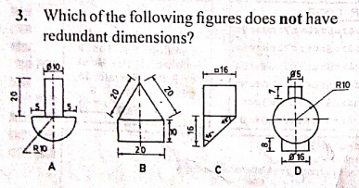

1. In a regular decagon, the interior angle is ___________
2. 1440
3. 1350
4. 1080
5. 1200
6. In representative fraction, the ratio of the numerator to denominator is _________
7. shows the ratio of the drawn size to the natural size
8. shows the ratio of natural size to the drawn size
9. represents the number of times the actual size is drawn
10. denotes the actual size of the drawn object
11. How many faces has a tetrahedron?
12. Four
13. Five
14. Six
15. Seven
16. A triangle whose side ratio is 4:7:4 is _____ triangle
17. scalene
18. isosceles
19. equilaterals
20. right angled
21. The locus of a point on the circumference of a circle as the circle rolls without slipping along a straight line is
22. trochoid
23. epicycloid
24. hypocycloid
25. cycloid

The figure shows above is the construction of a parabola, use it to answer questions 7 and 8

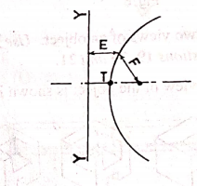

1. The part labelled Y-Y is ___ _______
2. a vertex
3. an axis
4. a directrix
5. a focus
6. If F is 20, E is ______
7. 15
8. 20
9. 25
10. 30
11. The figure shows below is the elevation of a triangular pyramid cut by plane Y-Y. The developmentis shown in

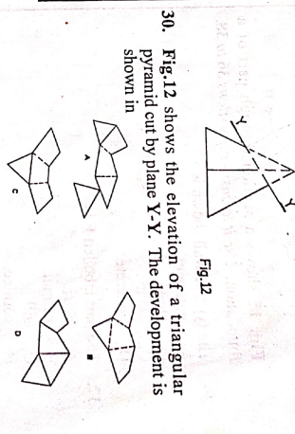



1. 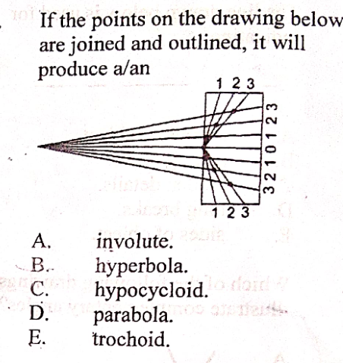If the points on the drawing below are joined and outlined, it will produced a/an
2. hyperbola
3. involute
4. parabola
5. hypocycloid
6. Which of the following statement is correct about the drawing below?

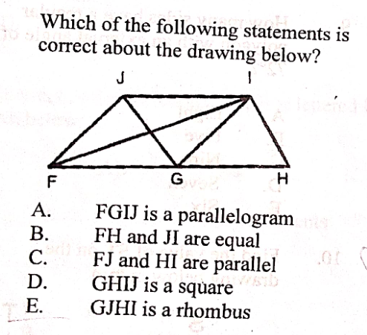

1. FGIJ is aparallelogram
2. FH and JI are equal
3. FI and HI are parallel
4. GHIJ is a square
5. Which of the following method is used to develop a prism?
6. Radial
7. Parallel
8. Triangulation
9. Approximate
10. Which of the following are true about □25 in the diagram below?

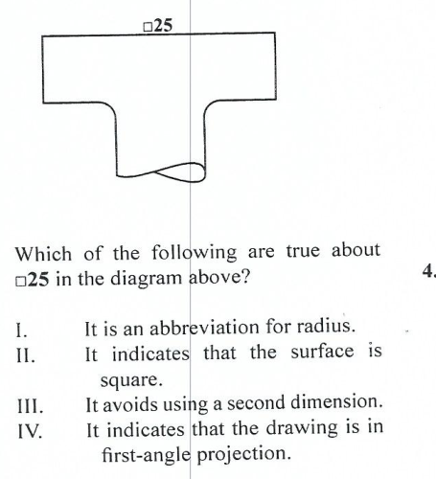

1. It is an abbreviation for radius
2. It indicates that the surface is square
3. It avoids using a second dimension
4. It indicates that the drawing is in first angle projection
5. I and II
6. I and III
7. II and III
8. II and IV
9. Which 0f the following construction is illustrated below?

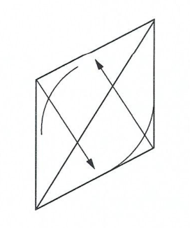

1. Construction circles
2. Construction of parabola
3. Irregular curve
4. Circle in isometric
5. The unfolding of an object into a flat sheet called pattern is referred to as ___

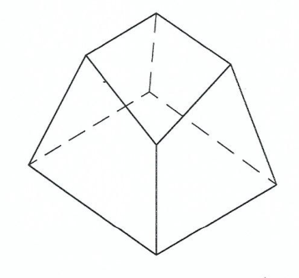

1. bisecting
2. loci
3. developing
4. machining
5. The diagram below illustrate the proper method of

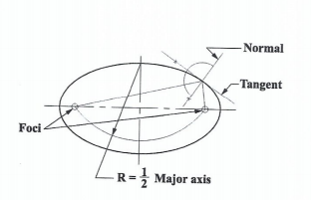

1. constructing an ellipse with tammel method
2. Construcing hyperbola as conic section
3. Finding foci, the normal and the tangent of an ellipse
4. Finding the foci, the normal and the tangent of a parabola
5. Which of the diagram below best represents internal and external tangent to two circles?

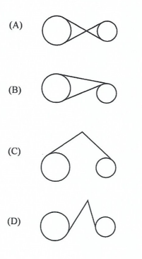

1. If a car picks up a tack on circumference of one of its tyre, then the path traced by the tack as the car is driven is called
2. a hyperbola
3. a parabola
4. a cycloid
5. a involute
6. The sketch below shows the development of

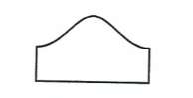

1. truncated prism
2. truncated cylinder
3. truncated pyramid
4. cylinder
5. Which of the following development shows a cylinder which is cut obliquely at both ends?

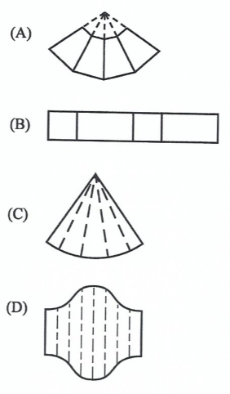

1. Which of the following instruments is used when drawing an irregular curve on a surface development?
2. Isometric template
3. French curve
4. Compass
5. Bow pen
6. The use of radial line method is s most suitable for the development of _____
7. right cone
8. cylindrical piep
9. oblique pyramid
10. cube
11. 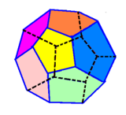 The regular polyhedral shown below is _____
12. icosahedron
13. octahedron
14. dodecahedron
15. tetrahedron
16. A development of an object is a drawing showing
17. one view
18. two views
19. pictorial sketch
20. the unfolding of the surface
21. The figure below shows the construction of _____

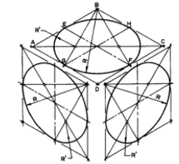

1. ellipse
2. isometric circle
3. circle
4. oblique circle
5. Which of the following is a view of a square pyramid?

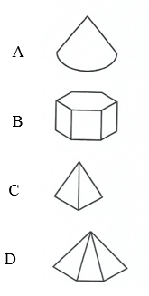

1. A polyhedron with two end join by rectangular faces is called.
2. prism
3. regular
4. pyramid
5. revolution
6. In the dimensioning , the line labelled K is referred to as _______ line

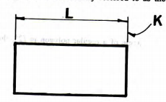

1. Reference line
2. datum
3. directrix
4. vertical
5. A students falls and hits head hard against the edge of technical drawing table. He is most likely to suffer from a
6. Concussion
7. Laughing fit
8. Heart attack
9. Nervous breakdown
10. Which of the number dimension below represents location dimensioning?

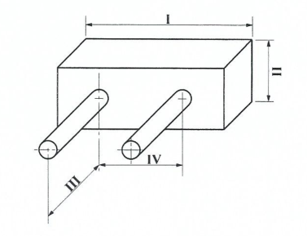

1. I
2. II
3. III
4. IV
5. Which of the following is NOT a method of constructing ellipse?
6. Rectangular
7. Radial
8. Trammel
9. Approximately
10. The figure below shows a right cone cut by plane XX parallel to side JK. What is the true shape of the cut surface?

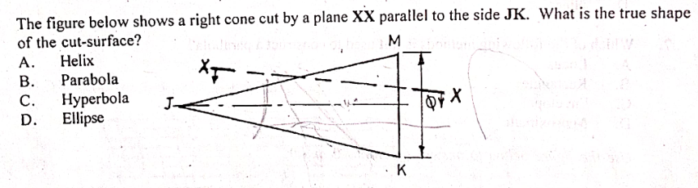

1. Helix
2. Parabola
3. Hyperbola
4. Ellipse
5. A circle appears as _____in isometric projection.
6. sphere
7. circle
8. ellipse
9. torus
10. Which of the construction below shows the unwinding of a string from a circle freely.

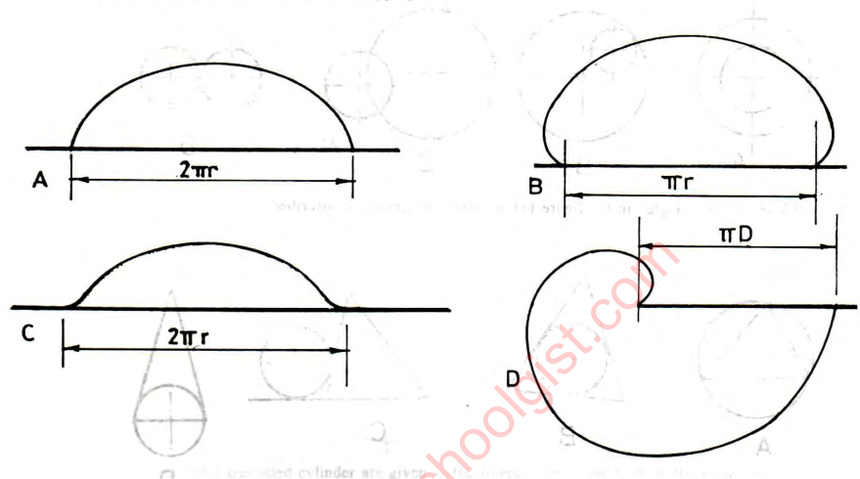

1. Which of the following is NOT required to construct a parabola?
2. Directrix
3. Focus
4. vertex
5. minor axis
6. Which of the following method is not used to construct hyperbola?
7. Trammel method
8. Rectangular method
9. Circumscribing rectangle method
10. Loci method
11. Which of the following curves has eccentricity less than one?

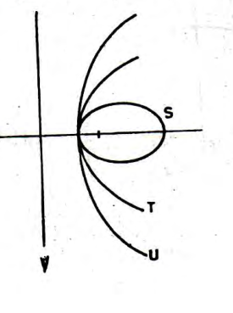

1. S
2. U
3. T
4. V
5. The figure below is ______

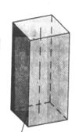

1. Right prism
2. Oblique prism
3. Truncated prism
4. Frustum of prism
5. The solid figure shown below is ______

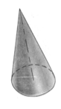

1. right cone
2. oblique cone
3. truncated cone
4. cycloid
5. The indication of size, shape and other information on drawing is
6. dimension
7. written
8. lettering
9. alphanumeric

**PAPER 2**

**GEOMETRY**

**(60 MARKS)**

***Answer three questions from this Part.***

1. *(a) The sketch in Figure shows points M and N, 50 apart. Point P moves such that  its distance from M and N is always in the ratio of 2:1.*

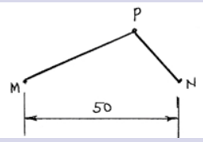

*Plot the locus of point P for one revolution.*

*Technical Drawing 2, May/June 2023,Q.3a (10 marks)*

*b. The major and minor axes of an ellipse are 110 mm and 80 mm respectively. Construct*

*(a) the ellipse using focal points method;*

*(b) a tangent and a normal to the ellipse at a point P above the major axis and 30 mm from the right end of the major axis. WASSC 2008, Q.2 (10 marks)*

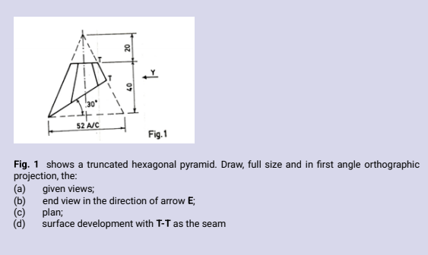

(a) . The figure above Shows a truncated hexagonal pyramid. Draw full size and first angle orthographic projection the:

i. The given view (5 marks)

ii. end elevation in direction of arrow Y. (5 marks)

iii. plan (3 marks)

iii. The surface development with T-T as the seam. (7 marks)

Technical drawing 2, WASSCE (PC2nd) 2020, Q. 2

1. The figure below shows the front elevation and incomplete plan of a truncated square pyramid

(a) copy the given views (7 marks)

(b) complete plan (7 marks)

(c) construct the surface development (without base) using P-P as the seam (10 marks)

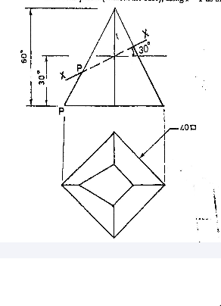

Technical drawing 2, May/june 2011. Q. 3

1. (a) Construct an involute to circle R20, starting from the lowest point of the circle and in a clockwise direction. (12 marks)

(b) Draw a tangent to the involute at a point P, which is located on the involute 70 to the roght of the vertical centre line. WASSCE (SC) 2021, Q.3 (8 marks)